Rules:
- You may not communicate with other students during the test.
- You may not copy answers from online forums.
- You may not copy answers from other students.
- You may not share your answers with other students for any reasons.
- Except for equations and diagrams answers should be typed not hand-written.

Marks or your entire test may be deleted with no marks if your answer is similar to the answer of other students, even if you are the person who originally wrote the answer.

Please edit and submit this document to QMPlus.

Student name | QM student number | Class number
Wu Tangxun | 200978947 | 2020213248

Question 1:
Eight servers are connected to eight clients via a common shared link. The clients have bandwidth R_{c} the servers have bandwidth R_{s} and the bottle neck link has capacity R. Each server connects to a different client. R_{s}=8Mb/s R_{c}=10,000Kb/s and R=70Mb/s. The end-to-end delay (propagation time) between the server and the client is 0.4ms.

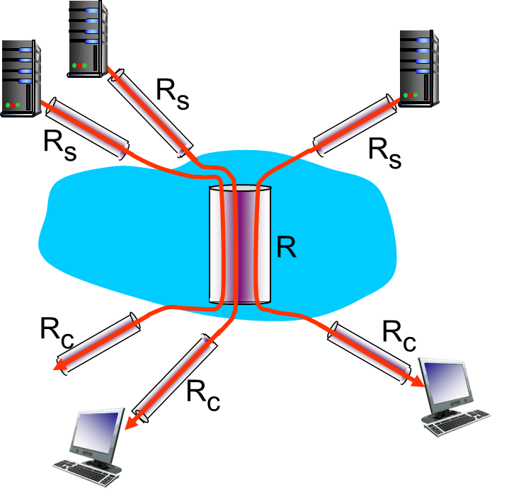

  - What is the maximum throughput available to each connection (1 mark)
Rc = 10000Kb/s = 10Mb/s
Rs = 8Mb/s
R/8 = (70Mb/s) / 8 = 8.75 Mb/s
therefore the maximum throughput available to each connection is 8Mb/s
  - A connection sends a stream of packets of length 200 bytes using stop and wait. What is the utilisation of the connection assuming there is no loss or queuing delay? Show your working. (4 marks)
packet length: 200 Bytes = 200 * 8 bits = 1600 bits
the end – to – end delay = 0.4 ms, so the RTT = 0.8 ms
Therefore, the time spent = RTT + L/Rs = 0.8ms + 0.2ms = 1 ms
The utilisation = (L/R) / (RTT + L/R) = 0.2
  - Instead of stop and wait packets are sent “pipelined” in groups of N. If there are no other sources of queuing and loss in the system how large can N be before queuing must occur? (1 mark)
In this case, it means sending N packets while using the same total time
so the utilisation = N*(L/R) / (RTT + L/R) = 0.2 N
when the utilisation equals to 1, the queuing may occur, N = 5

Question 2: Consider the following network where the router is a NAT box. The internal network in blue is a 10.0.0.0/24 private address space with three hosts (10.0.0.1, 10.0.0.2, 10.0.0.3) and the interface to the router/NAT box 10.0.0.4. The external interface to the router has the public IP address 138.76.29.7 and all addresses not in the 10.0.0.0/24 network must go through this interface.

The host at 10.0.0.1 sends a packet using TCP with src port 2345, dst IP 134.23.34.56 dst port 443.
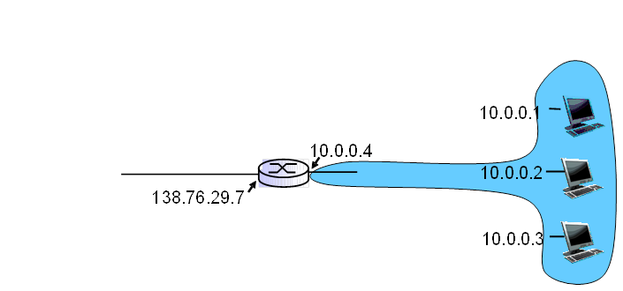
- The NAT box will alter the packet as it leaves interface 138.76.29.7 – assume the NAT box randomly chooses port 1234 to track this connection. Give the new src IP, src port, dst IP, dst port when the packet exits the NAT box through the interface 138.76.29.7. (1 mark)
new src IP: 138.76.29.7
src port: 1234
dst IP: 134.23.34.56 (unchanged)
dst port: 443 (unchanged)
- What entry is made in the WAN and LAN side of the NAT translation table. (1 mark)
WAN side address: 138.76.29.7, 1234
LAN side address: 10.0.0.1, 2345
- The server at IP 134.23.34.56 replies to the packet. Give the src IP, src port, dst IP, dst port when the packet leaves the server (1 mark)
src IP: 134.23.34.56
src port: 443
dst IP: 138.76.29.7
dst port: 1234
- Finally give the src IP, src port, dst IP, dst port after the packet returns through the NAT box (1 mark)
src IP: 134.23.34.56
src port: 443
dst IP: 10.0.0.1
dst port: 2345

Question 3: This question is about multiple access algorithms.

1
1
1
1

3
2
3
3
node 1
node 2
node 3

2

- Given the transmission pattern above for slotted ALOHA, which nodes have transmitted successfully? (2 marks)
because node 1 and node 3 occupy the full rate in specific time slot separately,
Node 1 and node 3 have transmitted successfully.
- Which of these properties are true for slotted ALOHA (1 marks)
  - when one node wants to transmit, it can send at rate R.
  - when M nodes want to transmit, each can send at average rate R/M
  - fully decentralized (no special node to coordinate transmissions, no synchronization of clocks)
  - Simple
true: a. d.
- Which of these properties are true for unslotted ALOHA (1 marks)
  - when one node wants to transmit, it can send at rate R.
  - when M nodes want to transmit, each can send at average rate R/M
  - fully decentralized (no special node to coordinate transmissions, no synchronization of clocks)
  - Simple
true: a. c. d.

Question 4: With reference to Figure 1, use Dijkstra’s algorithm to produce the Shortest Path Tree originating at node u. Fill in the table showing cost to each node D(*) and predecessor p(*) at each step. (6 marks)
6

4
w
v
5
2
u
z
2
1
4
1
2
y
x

2

Figure 1:- Network Topology
N’ | D(v) p(v) | D(w) p(w) | D(x) p(x) | D(y) p(y) | D(z) p(z)
u | 2 u | 6 u | 1 u | ∞ | ∞
ux | 2 u | 5 x |  | 3 x | ∞
uxv |  | 5 x |  | 3 x | ∞
uxvy |  | 4 y |  |  | 5 y
uxvyw |  |  |  |  | 5 y
uxvywz

